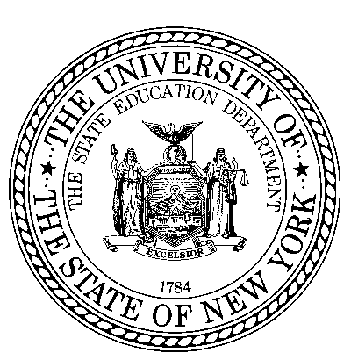

**THE STATE EDUCATION DEPARTMENT** / THE UNIVERSITY OF THE STATE OF NEW YORK / ALBANY, NY 12234

OFFICE OF ADULT CAREER AND CONTINUING EDUCATION SERVICES - Vocational Rehabilitation

89 Washington Avenue – Room 580 EBA

Albany, NY 12234

(518) 473-1626 - P

(518) 486-6252 - F

Dear School Administrator:

The start of the school season is upon us and ACCES-VR looks forward to working with you and your students. We recognize that unlike the beginning of any other school year, there continues to be much uncertainty due to the COVID-19 pandemic. While ACCES-VR has made changes to support appropriate social distancing and communication practices in response to COVID-19, we look forward to continuing to collaborate with you to support your students’ transition from school to work. Below is some information about ACCES-VR and its processes, including changes due to COVID-19, that will assist your students with making the transition to ACCES-VR services.

* ACCES-VR Orientation: Due to COVID-19, ACCES-VR is currently not providing in-person orientation. It is anticipated that ACCES-VR will deliver orientation remotely. Additional information will be shared with school districts when it becomes available.

As a reminder, ACCES-VR’s orientations are for everyone interested in receiving services. These presentations provide an overview of ACCES-VR services and students’ rights and responsibilities and are designed to help students and families make an informed decision about applying to ACCES-VR.

* Applying for ACCES-VR Services: Assisting a student and their family in fully completing the ACCES-VR application will help to avoid delays in the determination of eligibility and receipt of services. This includes making sure that:
  + Applications are submitted as early in the school year as possible.
  + The ACCES-VR application is signed by the student and, when the student is under 18 or has an appointed legal guardian, their parent/legal guardian.
  + All release of information forms are signed by the student and, when the student is under 18 or has an appointed legal guardian, their parent/legal guardian. These forms need to be included with the application.
  + Documentation relevant to the student’s disability (e.g. IEP, psychological assessment, 504 Plan) is included with the application so that an eligibility determination can be made.

**Note:** ACCES-VR determines eligibility for services based upon the person’s disability, whether they have the ability to benefit from vocational rehabilitation services, and that they require vocational rehabilitation services to gain employment. Additionally, upon application to ACCES-VR, students who are not United States citizens will need to provide documentation that they are legally allowed to work in the United States as determined by the United States Department of Immigration and Naturalization Services.

* ACCES-VR Intake: Due to COVID-19, ACCES-VR is currently not holding any in-person meetings either in their offices, in schools, or at other community locations. All intake appointments will be scheduled remotely (e.g. telephone, Zoom). Intakes should be scheduled starting in the Fall of each school year. This allows enough time for the student and the ACCES-VR counselor to establish a counseling relationship and develop an Individualized Plan for Employment (IPE) prior to school exit. Ideally, remote meetings with students should begin in October and end in May. **Note:** For students under the age of 18, or with an appointed legal guardian, an ACCES-VR application and release of information form must be signed by the student and parent/legal guardian prior to an ACCES-VR counselor remotely meeting with a student or receiving any records. Please schedule remote intake meetings accordingly.
* ACCES-VR Services:
  + *Pre-Employment Transition Services:* ACCES-VR provides pre-employment transition services, or Pre-ETS, to students. Pre-ETS are design to give students an early start to career exploration and exposure to the world of work and postsecondary options prior to their exiting from school. Referrals of students **before** their last year of school are encouraged as this will allow ACCES-VR counselors to discuss and provide these service options. **Note:** Depending on the location and type of service, Pre-ETS may be provided remotely or in-person, based on the choice of the student and their family, and utilizing COVID-19 precautions.
  + *Vocational or Educational Training for Employment:* ACCES-VR funds vocational rehabilitation services that will meet an individual’s agreed upon employment goal that leads to a job. When appropriate, this may include vocational training (career school) or educational training (BOCES or college). Please note, quite often vocational training at a career school will allow a student to achieve their employment goal and ACCES-VR counselors will also explore these options with students and families.

**Note: ACCES-VR is not a financial aid service or program. Financial support for college is not guaranteed. ACCES-VR financial support for college may only be considered when:**

* **The student and the ACCES-VR counselor have agreed upon an employment goal that requires a college degree, and**
* **The student meets ACCES-VR’s financial need threshold.**

**When vocational or educational training is provided all comparable benefits, such as awarded financial aid (e.g. Pell, TAP), are applied before ACCES-VR funds are utilized. Additionally, the maximum financial support provided by ACCES-VR for college tuition is at the SUNY/CUNY/Community College current published rate.**

The ACCES-VR District Office values our relationship with your school. We recognize that many changes have happened and while we all continue to face the unknowns of the COVID-19 pandemic, we hope that you will find this information helpful to our joint efforts to support students’ seamless transition from school to their future employment. If you have any questions, please contact your ACCES-VR liaison.